Project Report

Title of the Project: Fuzzy Graph Colouring

Under the guidance of
Prof. Arindam Dey

Submitted by
Pusala Praneetha 20BCI7323



VIT-AP UNIVERSITY
AMARAVATI
ANDHRA PRADESH, INDIA

ABSTRACT
Fuzzy graph colouring is a mathematical concept that extends traditional graph colouring by assigning degrees of membership rather than discrete values to the colour classes. In this approach, nodes can have partial colours that represent the degree of their association with a particular colour. This allows for a more nuanced and flexible approach to graph colouring, which can be useful in a variety of applications, such as image processing, computer vision, and machine learning. This abstract provides a brief overview of fuzzy graph colouring and its potential applications, highlighting its advantages over traditional graph colouring approaches.

KEYWORDS:
Fuzzy graph, $α-cut$, Chromatic number

INTRODUCTION
Graph colouring is a classical problem in graph theory that has numerous practical applications. The objective of graph colouring is to assign colours to vertices of a graph in such a way that adjacent vertices do not have the same colour. The most common approach to graph colouring is to use discrete values (i.e., integers) to represent colours. However, in many applications, a more flexible and nuanced approach is needed to represent the degree of association between vertices and colours. This is where fuzzy graph colouring comes in. The objective of this article is to provide a detailed overview of fuzzy graph colouring, including its mathematical foundations, algorithms for solving the problem, and applications in various fields. Fuzzy graph colouring has numerous potential applications, such as image processing, computer vision, and machine learning. For example, in image processing, fuzzy graph colouring can be used to segment images based on colour similarity, while in machine learning, it can be used to cluster data points based on their similarity to different categories.
Fuzzy graph coloring is an extension of traditional graph coloring in which rather of assigning each vertex a separate color, each vertex is assigned a degree of class in each color. This allows for a more flexible and nuanced approach to coloring graphs. In fuzzy graph coloring, the ideal is to find a coloring of the vertices of a graph similar that no conterminous vertices have the same or veritably analogous degree of class in the same color. The degree of class of a vertex in a color can range from 0 to 1, with 0 indicating no class in that color and 1 indicating full class. Fuzzy graph coloring has operations in colorful fields, including computer wisdom, operations exploration, and engineering. It can be used in scheduling problems, resource allocation, and decision- making processes where query and imprecision are present. working fuzzy graph coloring problems can be challenging due to the large number of possible colorings, but there are colorful heuristic and metaheuristic algorithms that can be used to find approximate results.

Preliminary Notes
Fuzzy graph coloring is an extension of the traditional graph coloring problem, where rather of assigning a single color to each vertex, a degree of class of each vertex to different colors is defined. In other words, each vertex has a fuzzy color assigned to it. Fuzzy graph coloring has operations in several fields, including scheduling, resource allocation, and network design. It allows for further flexible results in scripts where hard constraints aren't suitable or practical. The ideal of fuzzy graph coloring is to minimize the sum of the class degrees of the vertices to their assigned colors, subject to the constraint that conterminous vertices must have different colors. This is a grueling optimization problem that requires to be advanced fine ways and algorithms. One of the most common approaches to working fuzzy graph coloring problems is through the use of heuristics and metaheuristics. These styles are designed to explore the result space efficiently and find good-quality results in a reasonable quantum of time. Fuzzy graph coloring is an active exploration area with numerous open problems and challenges. Some of the current exploration directions include the development of new algorithms, the study of the parcels of fuzzy graphs, and the operation of fuzzy graph coloring in real-world scripts. Overall, fuzzy graph coloring is a fascinating and important area of exploration that has the implicit to give new receptivity and results to numerous practical problems.

DEFINITION:
A fuzzy set A defined on X can be characterized from its family of α-cuts Aα = {x∈X/ µA(x)≥α} α∈I. This family of sets is monotone, i.e., for α,β∈I α ≤ β we have Aα ⊇ Aβ On the other hand, given a finite monotone family { Aα p / p∈{1,….m}}, a fuzzy set can be defined from the membership function µA(x) = sup{ P α / x∈Aα p } for every x∈X. Let {Gα = (V,Eα)/ α∈I} be the family of α-cuts of Ĝ, where the α-cut of a fuzzy graph is the crisp graph Gα = (V,Eα) with Eα = {{i,j}/i,j∈V,µij≥α}. Hence any crisp k-colouring π k α can be defined on Gα. The k-colouring function of Ĝ is defined through this sequence. For each α∈I, let χα denote the chromatic number of Gα. The chromatic number of Ĝ is defined through a monotone family of sets.

MAIN RESULTS:
We have a fuzzy graph G=(V, µ) where V={0,1,2,3}.This fuzzy graph is depicted in fig 1 and the matrix µ is
µ=$\left[\begin{matrix}- & 0.5 & 0.3 & 0 \\ 0.5 & - & 0.7 & 0 \\ 0.3 & 0.7 & - & 0.9 \\ 0 & 0 & 0.9 & -\end{matrix}\right]$

GRAPH:
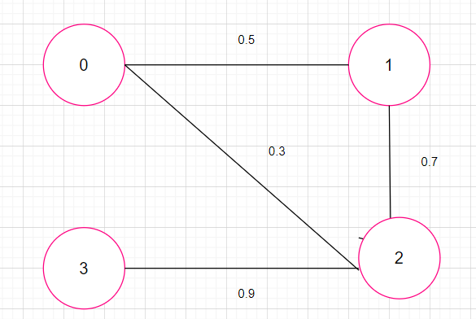
For $α >=0.5$ ; Chromatic number=3
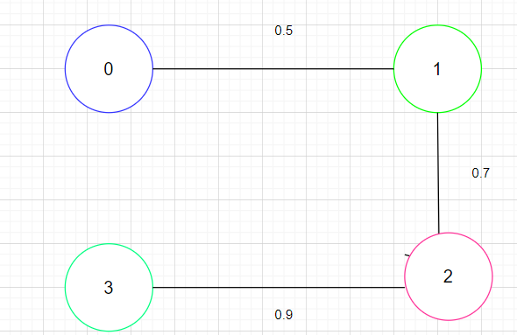

For $α >=0.7$; Chromatic number=3
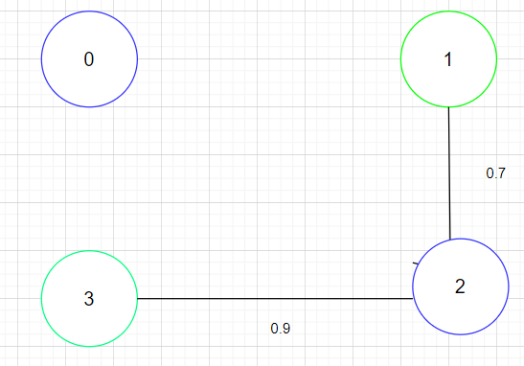
For $α >=0.6$; Chromatic number=2
ALGORITHM:
- Define a function called color FuzzyGraph which takes input parameters: a. adj Matrix: A two- dimensional array of integers representing the adjacency matrix of the graph.
b. fuzzyValues: An array of double values representing the fuzzy values of the vertices.
c. numColors: An integer representing the maximum number of colors that can be used to color the graph.
- Initialize an array colors with -1 as its default value.
- Put all vertices in a priority queue pq, with the vertex with highest degree as the front element.
- Loop while pq is not empty:
a. Dequeue the front element u from the pq.
b. Create a boolean array available of size numColors which will help determine which colors are available to color u.
c. For each vertex v adjacent to u, if v has already been colored with a color, then mark that color as not available if fuzzyValues [u] is greater than $α$.
d. Select the first color i that is available for u.
e. Color the current vertex u with color i.
f. Repeat from step 4a until all vertices have been colored.
- Print the color assigned to each vertex.
- In the main function:
a. Construct an adjacency matrix adj Matrix of the graph.
b. Define an array fuzzyValues containing the fuzzy values of the vertices.
c. Define an integer numColors representing the number of colors that can be used to color the graph.
d. Call the function color FuzzyGraph with inputs adjMatrix, fuzzyValues, and numColors

CONCLUSION:
In this paper we defined the fuzzy chromatic number as fuzzy numbers through the α- cuts of the fuzzy graph which are crisp graphs. Depending upon the $α$value the chromatic number varies for each case.

REFERENCE:
https://www.researchgate.net/publication/276464981_Fuzzy_colouring_of_fuzzy_graphs
https://www.sciencepub.net/report/roj130121/01_36893roj130121_1_4.pdf
https://citeseerx.ist.psu.edu/document?repid=rep1&type=pdf&doi=cb44940d90e29fab6aa8f2d738c320ef8caf98b5
https://www.sciencedirect.com/science/article/abs/pii/S0305048304000660

